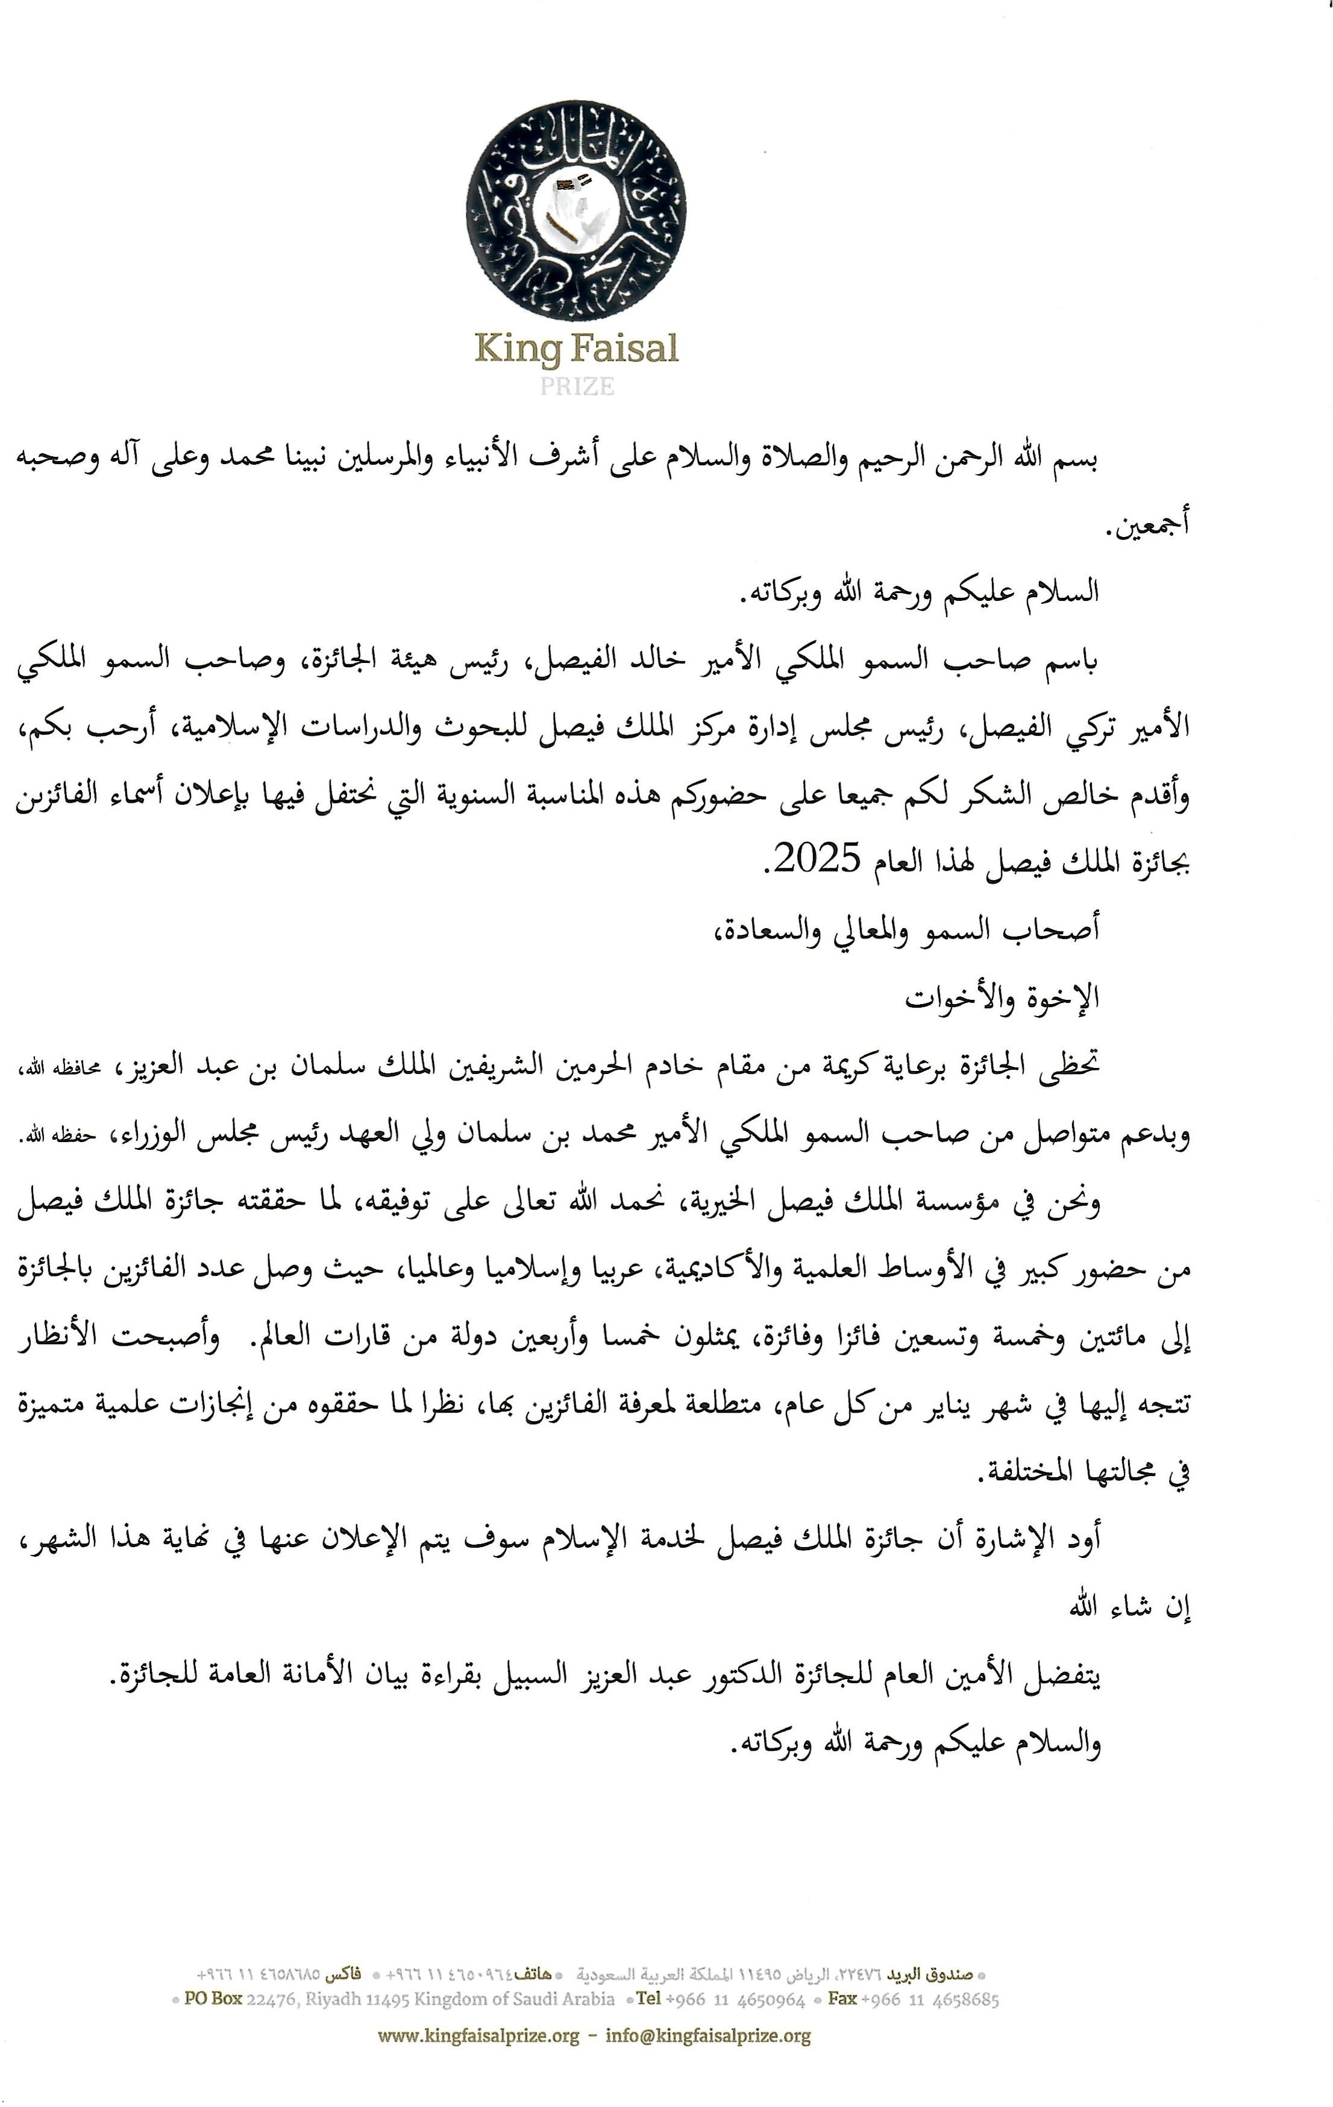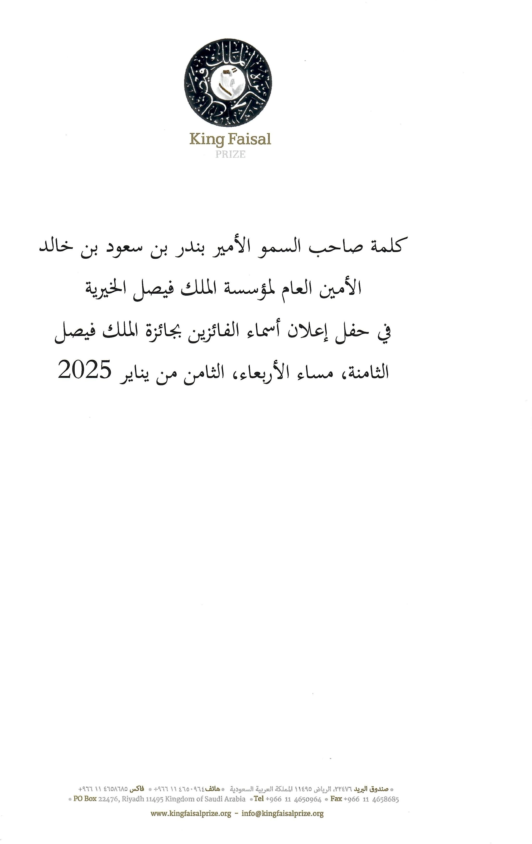

Speech of His Royal Highness Prince Bandar bin Saud bin Khalid,  
Secretary-General of the King Faisal Foundation

At the ceremony for announcing the names of the 2025 laureates of the King Faisal Prize.

On the evening of Wednesday, January 8, 2025.

In the name of Allah, the Most Gracious, the Most Merciful.

Peace and blessings be upon the most honorable of prophets and messengers, our Prophet Muhammad, and upon his family and companions.

**Dear all,**

**Peace, mercy, and blessings of Allah be upon you.**

On behalf of His Royal Highness Prince Khalid Al-Faisal, Chairman of the Prize Committee, and His Royal Highness Prince Turki Al-Faisal, Chairman of the Board of Directors of King Faisal Center for Research and Islamic Studies, I am pleased to welcome you and extend my sincere gratitude for your presence at this annual event, during which the names of the laureates of the King Faisal Prize for 2025 will be announced.

The prize is honored by the continuous patronage of the Custodian of the Two Holy Mosques, King Salman bin Abdulaziz, may Allah protect him, and the ongoing support of His Royal Highness Crown Prince Mohammed bin Salman bin Abdulaziz, Prime Minister, may Allah protect him.

Over the years, the King Faisal Prize has been able, with Allah's guidance, to achieve its goals and gain a prestigious global reputation in scientific and academic circles. This is evident from the increasing number of laureates, which has reached 295 winners from 45 countries worldwide, and from the global recognition the Prize enjoys year after year due to its selection of deserving laureates known for their outstanding achievements in various fields.

I would like to note that the King Faisal Prize for Service to Islam will be announced at the end of this month, God willing.

The Secretary-General of the Prize, Dr. Abdulaziz Alsbeil, will now read the general secretariat announcement of the Prize.

**Peace, mercy, and blessings of Allah be upon you.**

